PREDICTIVE ANALYTICS FOR EXPORT FORECASTING USING ARIMA AND LSTM
ABSTRACT
Accurate forecasting of export trends is crucial for economic planning, policy formulation, and business strategy in international trade. Traditional forecasting methods often fail to capture complex patterns, seasonality, and non-linear trends in export data. This project proposes a predictive analytics framework for export forecasting using ARIMA (AutoRegressive Integrated Moving Average) and LSTM (Long Short-Term Memory) models. ARIMA is utilized to model linear trends and seasonality in historical export data, while LSTM, a type of recurrent neural network, captures non-linear dependencies and long-term temporal patterns. The combined approach allows for improved prediction accuracy by leveraging the strengths of both statistical and deep learning models. Experimental results on real-world export datasets demonstrate that the proposed system can effectively forecast future export values, providing valuable insights for policymakers, exporters, and businesses to make informed decisions. This approach highlights the potential of integrating traditional time series methods with advanced machine learning techniques for economic forecasting.
OBJECTIVE
The primary objective of this project is to develop a predictive system for forecasting export trends using advanced time series and machine learning models. The system aims to analyze historical export data and identify patterns, trends, and seasonal effects. By applying ARIMA for linear trend modeling and LSTM for capturing non-linear and long-term dependencies, the project seeks to generate accurate and reliable forecasts for future export values.

The secondary objective is to provide actionable insights for policymakers, businesses, and exporters to support strategic decision-making. Accurate export forecasts can help in planning production, managing inventory, optimizing supply chains, and formulating trade policies. By integrating statistical methods with deep learning techniques, the system aims to improve forecast accuracy compared to traditional methods, enabling proactive planning and better risk management in international trade.
INTRODUCTION
Accurate forecasting of exports is a critical aspect of economic planning and business strategy in global trade. Export trends are influenced by multiple factors, including demand fluctuations, seasonal variations, geopolitical changes, and market dynamics. Traditional forecasting methods, such as moving averages or simple regression models, often fail to capture complex patterns, seasonality, and non-linear relationships in historical export data. As a result, businesses and policymakers may face difficulties in making informed decisions regarding production, supply chain management, and trade policies.
Advances in predictive analytics and machine learning provide new opportunities to improve the accuracy of export forecasts. Time series models like ARIMA (AutoRegressive Integrated Moving Average) are effective for capturing linear trends and seasonal effects in data, while deep learning models like LSTM (Long Short-Term Memory) networks can model non-linear patterns and long-term dependencies. By combining these approaches, it is possible to leverage the strengths of both statistical and machine learning methods, enabling more robust and reliable predictions for export volumes.
This project focuses on developing a hybrid predictive analytics system for export forecasting using ARIMA and LSTM models. The system involves data collection, preprocessing, model training, and evaluation to generate accurate future export estimates. By providing actionable insights from historical export data, the project aims to support businesses, exporters, and policymakers in making informed decisions, optimizing resource allocation, and improving economic planning. The approach highlights the potential of integrating traditional time series techniques with advanced machine learning methods for practical economic forecasting.
PROBLEM STATEMENT
Accurate export forecasting is essential for economic planning, business strategy, and trade policy formulation. Traditional forecasting methods, such as moving averages, linear regression, and basic time series analysis, often fail to capture the complex patterns, seasonal variations, and non-linear trends present in export data. This limitation can lead to inaccurate predictions, resulting in poor decision-making, supply chain inefficiencies, and missed business opportunities.
There is a need for a data-driven predictive system that combines statistical and machine learning approaches to improve forecast accuracy. By integrating ARIMA, which captures linear trends and seasonality, with LSTM networks, which handle non-linear and long-term dependencies, it is possible to generate reliable export predictions. Such a system can provide actionable insights for businesses, exporters, and policymakers, enabling them to plan production, manage inventory, optimize trade strategies, and reduce financial risks associated with inaccurate forecasts.

EXISTING SYSTEM
Currently, export forecasting is primarily performed using traditional statistical methods such as moving averages, linear regression, and basic ARIMA models. These methods analyze historical export data to estimate future trends and provide insights for planning. Some businesses may also rely on expert judgment, past experience, or simple spreadsheet-based projections to predict exports. While these approaches are useful for short-term estimates, they have limited ability to handle complex patterns, non-linear trends, and sudden market fluctuations.
DISADVANTAGES
The existing system has several limitations. Traditional methods are often inaccurate for long-term forecasting because they cannot fully capture non-linear patterns or long-term dependencies in export data. They also fail to account for sudden changes in market conditions, global trade policies, or seasonal variations. Manual forecasting methods are time-consuming and prone to human error, and they may not provide actionable insights for data-driven decision-making. As a result, businesses and policymakers face the risk of misallocation of resources, supply chain inefficiencies, and financial losses due to inaccurate export predictions.
PROPOSED SYSTEM
The proposed system is a hybrid predictive analytics model for export forecasting that combines ARIMA and LSTM models to improve prediction accuracy. ARIMA is used to model linear trends and seasonality in historical export data, while LSTM, a type of recurrent neural network, captures non-linear patterns and long-term dependencies. The system involves data collection, preprocessing, model training, and evaluation, producing accurate forecasts of future export values. A user-friendly dashboard can visualize predictions and trends, helping businesses and policymakers make informed decisions regarding production, inventory management, and trade planning.
ADVANTAGES
The proposed system offers several benefits over traditional forecasting methods. It provides higher accuracy by combining the strengths of statistical (ARIMA) and deep learning (LSTM) models, capturing both linear and non-linear patterns. The system can handle large datasets and complex dependencies, making it suitable for real-world export data. It reduces human error and automates the forecasting process, saving time and effort. By generating actionable insights, the system helps businesses optimize production, plan inventory, reduce risks, and support policymakers in formulating effective trade strategies based on reliable export predictions.
SYSTEM ARCHITECTURE
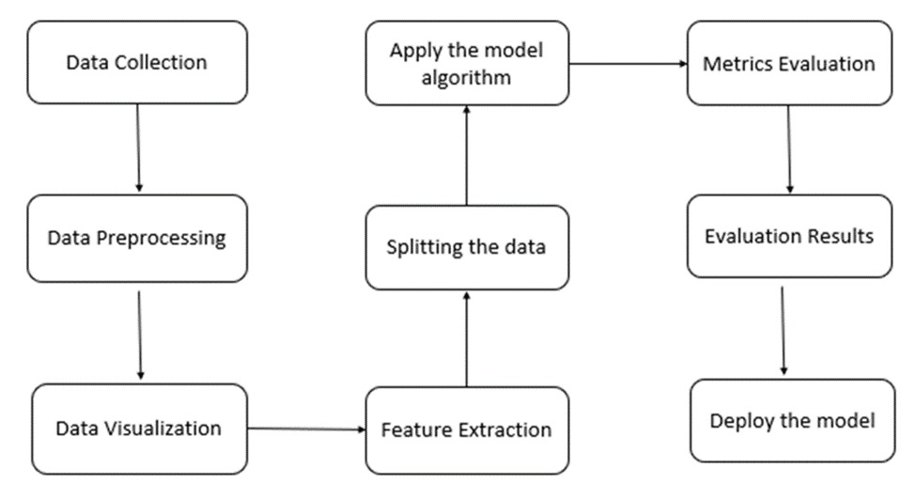
HARDWARE REQUIREMENTS
Processor (CPU) Intel Core i5/i7 or equivalent, 2.5 GHz
RAM Minimum 8 GB
Storage At least 500 GB HDD or SSD

SOFTWARE REQUIREMENTS
Operating System Windows 10/11,
Programming Languages Python 3.x
Web Framework Flask
REFERENCE
- Box, G. E., Jenkins, G. M., Reinsel, G. C., & Ljung, G. M. (2015). Time Series Analysis: Forecasting and Control. Wiley.

- Hochreiter, S., & Schmidhuber, J. (1997). Long Short-Term Memory. Neural Computation, 9(8), 1735–1780.

- Makridakis, S., Wheelwright, S. C., & Hyndman, R. J. (2018). Forecasting: Methods and Applications. Wiley.

- Zhang, G., Eddy Patuwo, B., & Hu, M. Y. (1998). Forecasting with Artificial Neural Networks: The State of the Art. International Journal of Forecasting, 14(1), 35–62.

- Khashei, M., & Bijari, M. (2011). A Hybrid Artificial Neural Network–ARIMA Model for Time Series Forecasting. Applied Soft Computing, 11(2), 2664–2675.

- Wang, Y., Yu, L., & Fong, S. (2019). LSTM-Based Deep Learning Models for Time Series Prediction in Economic and Trade Data. IEEE Access, 7, 113112–113122.

- Choi, T. M., & Ding, X. (2020). Forecasting International Trade with Machine Learning: ARIMA and LSTM Approaches. International Journal of Production Economics, 227, 107659.

- Zhang, Y., & Qi, M. (2005). Neural Network Forecasting for Seasonal and Trend Time Series. European Journal of Operational Research, 160(2), 501–514.

- Hyndman, R. J., & Athanasopoulos, G. (2021). Forecasting: Principles and Practice. OTexts.

- Khashei, M., Bijari, M., & Shamsuddin, S. M. (2012). A Novel Hybridization of ARIMA and Artificial Neural Networks for Economic Forecasting. Expert Systems with Applications, 39(1), 108–115.

